3000 gm latex balloon
15 ft 500# woven nylon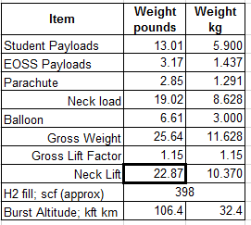

Item | Weight pounds | Weight kg
Student Payloads | 19.84 | 9.000
EOSS Payloads | 3.17 | 1.437
Parachute | 2.85 | 1.291
Neck load | 25.86 | 11.728
Balloon | 6.61 | 3.000
Gross Weight | 32.47 | 14.728
Gross Lift Factor | 1.15 | 1.15
Neck Lift | 30.73 | 13.935
H2 fill; scf (approx) | 505
Burst Altitude; kft km | 101.4 | 30.9

8.5 ft parachute w/ fast release 1.291 kg (2.85#)

AE0SS CW/cutdown
147.555 MHz 0.400 kg (0.88#)

KØSCC-9 APRS
144.360 MHz 0.35W 0.300 kg (0.66#) Slotted at 0:10 and 0:40
www.wxqa.com/sss/balon1.cgi
KØSCC-9 / EOSS-242

5 ft 500# woven nylon

6 x Colorado Space Grant Consortium DemoSats
Total wt (est): 5.7 kg (12.6 #)
2 ft

Colorado Space Grant Eclipse Common payload
Total wt (estimated): 2.5 kg (5.51 #)

20 ft 500# woven nylon

www.wxqa.com/sss/balon1.cgi
KEØBMU-11 / EOSS-242
KEØBMU-11 APRS
Slotted 0:10 and 0:40
144.340 MHz 0.3W 0.737 kg (1.62#)

8.5 ft parachute 1291 gm
w/ fast release 2.8#

